COVID-19 DATA EXPLORATION PROJECT
Project Overview:
The main objective of the project is to explore the Global COVID 19 dataset and extract the meaningful insights and present the findings in the form of visualisations by using the data Analysis and Visualization Tools.

Tools Used:
SQL Server Management Studio
Tableau

Objectives:
- Cleaning and preparing the dataset using SQL.
- Exploring the key metrics such as total cases, total deaths and infection rates.
- Calculating the important indicators like death percentage and percentage of population infected.
- Analysing the vaccination progress using the join and window functions.
- Creating structured dataset for visualization.
- Building an interactive dashboard using Tableau to present and communicate the findings effectively.

Data Profile:
Two datasets were used in this project.
- Covid Deaths Table:
- Contains information related to cases and deaths.
- Location
- Continent
- Date
- Population
- Total cases
- New cases
- Total deaths
- New deaths

- Covid Vaccination Table:
- Date
- Location
- Vaccinations
Data Cleaning
- Removed rows representing aggregated data (such as world or continent totals) by filtering records where the continent column was NULL.
- Handled missing values in columns like vaccinations using SQL functions to avoid calculation errors.
- Converted certain columns (e.g., deaths and vaccinations) to appropriate numeric data types for accurate calculations.
- Ensured the dataset contained only country-level data, making comparisons and analysis more reliable.

SQL Data Exploration
SQL exploratory analysis was performed to understand the spread and impact of COVID-19.
- Death Percentage Analysis:
The death percentage analysis was performed to measure the severity of the disease across different countries.
SELECT location, date, total_cases, total_deaths,
(CAST(total_deaths AS FLOAT) / total_cases) * 100 AS death_percentage
FROM CovidDeaths
WHERE continent IS NOT NULL
ORDER BY location, date;

- Infection Rate:
The infection rate was identified in respective to the population so as to identify the country with the highest infection rate.
SELECT location, population,
MAX(total_cases) AS highest_infection_count,
MAX((CAST(total_cases AS FLOAT) / population)) * 100 AS percent_population_infected
FROM CovidDeaths
WHERE continent IS NOT NULL
GROUP BY location, population
ORDER BY percent_population_infected DESC;

- Global Trends Over Time:
To analyse the pandemic trends over time
SELECT date,
SUM(new_cases) AS total_cases,
SUM(CAST(new_deaths AS INT)) AS total_deaths,
SUM(CAST(new_deaths AS INT)) * 100.0 / SUM(new_cases) AS death_percentage
FROM CovidDeaths
WHERE continent IS NOT NULL
GROUP BY date
ORDER BY date;

- Vaccination Progress Analysis:
- Vaccination data was analyzed by joining the deaths dataset with the vaccination dataset.
- A window function was used to calculate cumulative vaccinations, showing running total of vaccinations for each country.
SELECT
dea.location,
dea.date,
dea.population,
vac.new_vaccinations,
SUM(CONVERT(INT, ISNULL(vac.new_vaccinations,0)))
OVER (PARTITION BY dea.location ORDER BY dea.date) AS rolling_vaccinations
FROM CovidDeaths dea
JOIN CovidVaccinations vac
ON dea.location = vac.location
AND dea.date = vac.date
WHERE dea.continent IS NOT NULL;

- Vaccination Percentage Using CTE:
A Common Table Expression (CTE) was used to calculate the percentage of the population vaccinated for comparison of vaccination coverage across countries.
WITH PopVsVac AS
(
SELECT
dea.location,
dea.date,
dea.population,
vac.new_vaccinations,
SUM(CONVERT(INT,ISNULL(vac.new_vaccinations,0)))
OVER (PARTITION BY dea.location ORDER BY dea.date) AS rolling_vaccinations
FROM CovidDeaths dea
JOIN CovidVaccinations vac
ON dea.location = vac.location
AND dea.date = vac.date
WHERE dea.continent IS NOT NULL
)

SELECT *,
(rolling_vaccinations / population) * 100 AS vaccination_percentage
FROM PopVsVac;
Tableau Visualization:
After completing the data exploration using the SQL Server Management Studio the processed data was imported into Tableau to create an insightful dashboard.
The dashboard was designed to highlight infection rates, death counts, and global trends over time.
The dashboard visualizations:
- Global Cases and Death Percentage: A summary view displaying the total number of COVID-19 cases, total deaths, and the overall death percentage, providing a quick overview of the global impact of the pandemic.
- Death Count by Continent: A bar chart comparing total COVID-19 deaths across different continents, highlighting regional differences in mortality.
- Countries with Highest Infection Rate: A bar chart showing the percentage of the population infected in different countries, allowing comparison of infection levels relative to population size.
- Global Infection Trends Over Time: A time-series line chart illustrating how COVID-19 cases changed over time, helping identify major waves of the pandemic.

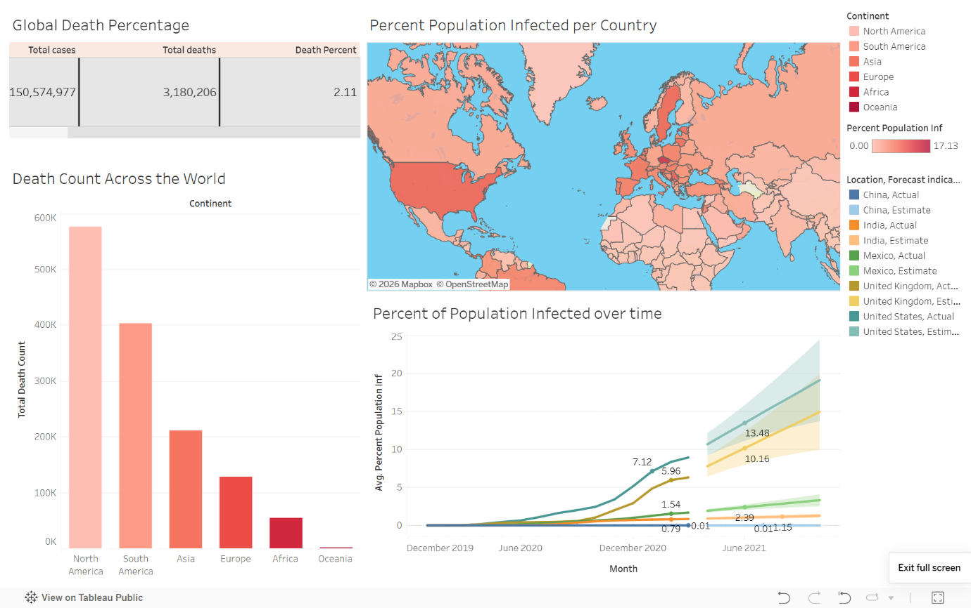

Insights from Tableau Dashboard
- The global COVID-19 dataset shows a total of 150,574,977 confirmed cases and 3,180,206 deaths, resulting in a global death percentage of 2.11%, as visualized in Tableau.
- United States recorded the highest total death count with 576,232 deaths, followed by Brazil with 403,781 deaths, and Mexico with 216,907 deaths. Other heavily affected countries include India with 211,853 deaths and United Kingdom with 127,775 deaths.
- The analysis of infection rates relative to population shows that Andorra experienced one of the highest infection rates, with approximately 17.12% of its population infected.
- At the continental level, North America recorded the highest death count, followed by South America and Asia, indicating that these regions were the most severely affected during the pandemic.
- The time-series visualization shows that infection percentages increased steadily from late 2020 through mid-2021, reflecting multiple waves of the pandemic across several countries.
- Countries such as United States, United Kingdom, and India showed sharp increases in infection percentage during early 2021, indicating major outbreak waves during that period.

CONCLUSION:
This project analyzed global COVID-19 data to understand patterns in infection rates, mortality, and overall pandemic trends. Data cleaning, transformation, and exploration were performed using SQL Server Management Studio, where SQL queries were used to calculate key metrics such as infection percentage and death percentage.
The insights obtained from the SQL analysis were then visualized using Tableau, where an interactive dashboard was created to present global cases, death counts by continent, countries with the highest infection rates, and infection trends over time.
Overall, the project demonstrates how SQL analysis in SQL Server Management Studio combined with visualization in Tableau can be used to transform raw data into meaningful insights and effectively communicate data-driven findings.

